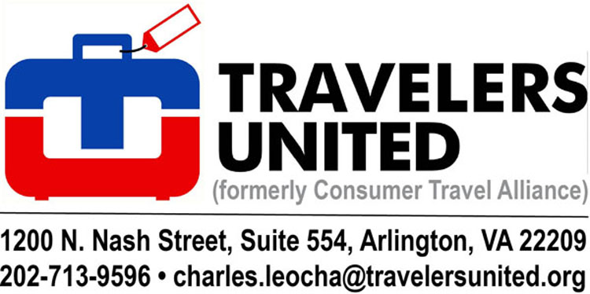 August 21, 2020

The Honorable Steven G. Bradbury
Deputy Secretary & General Counsel
Department of Transportation
1200 New Jersey Ave. SE
Washington, DC 20590

The Honorable Makan Delrahim
Assistant Attorney General for Antitrust
Department of Justice
900 Pennsylvania Ave. NW
Washington, DC 20530

RE: American Airlines (AA) and JetBlue (JBU) “Strategic Partnership”
AND the elimination of FAA slot controls at LGA, DCA, and JFK

Dear Deputy Secretary Bradbury and Assistant Attorney General Delrahim,

Travelers United, the largest Travel Advocacy Group in the United States, opposes the proposed code-sharing arrangements between AA and JBU. We also object to an extension of slot usage waivers at DCA, LGA, and JFK.

The AA/JBU proposal will significantly weaken the slot remedies that the DOJ imposed as a condition of approving the AA/USAir merger in 2013. The majority of JBU slots at DCA and at LGA were awarded to JBU by the government to provide independent low cost carrier (LCC) competition against the dominant legacy carriers, including American.

JetBlue’s “Strategic Partnership” with American will undermine its incentive to use the slots it has been awarded by the government against American.

Travelers United, at that time operating as Consumer Travel Alliance, was intimately involved with Congress, the DOT, the Department of Justice (DOJ), and aviation stakeholders when the AA/USAir merger was undergoing government review. Our organization crunched the numbers and showed the significant overlap on connecting flights between USAir and AA. We also highlighted the increased control of both DCA and LGA that would result from the proposed merger. Travelers United worked closely with DOJ to find a way to allow the merger to move forward after DOJ initially objected to the merger.

In the end, Travelers United thought DOJ conceded too much as consumers received a meager number of slot divestitures in order to maintain competition at LGA and DCA. Now, unfortunately, the proposed AA/JBU arrangement will significantly weaken the consumer protections gained at the time. DOJ was absolutely clear that the divestitures were imposed to enhance competition between low lost carriers and the legacy airlines.

As an example, the DCA-BOS market will lose competition because the only competing flights are operated by AA and JBU. It is clear that the very routing the DOJ used to highlight the efficacy of the divestiture proposals is now a glaring example of the competition that will be lost with the proposed arrangement between AA and JBU. This is true even if the carriers don’t plan to code share on this route because the partnership itself will undermine JetBlue’s incentive to compete against its “strategic partner.”

Consumer benefits from LCC entry are well established.

Studies by the DOJ during the AA/US merger showed that having an LCC on a nonstop route results in both significant price reductions and capacity increases. Repeated economic research confirms competition – whether by nonstop or connecting service – can lower airfares.

The DOT should not undermine the DOJ ordered remedy. After all members of the public are the ones ultimately paying the bills through increased taxes, increases in airfares and fees, restrictive airline-imposed rules, as well as possible reduction in services.

The AA/JBU joint venture should be considered along with the current slot waiver request

Travelers United was astounded when it learned after the passage of the CARES Act, that a full IATA 2020 Summer Season slot waiver had already been granted to the airlines waiving slot usage requirements through October 24, 2020. The waivers were agreed upon in secret airline, FAA, A4A negotiations, and not open to the public. They were justified as short-term help to airlines that faced massive flight cancellations.

Virtually everyone agrees that pre-pandemic airport congestion will not return for years. Why, therefore, should the government keep pre-pandemic slot controls in place when there is no need?

The FAA and DOT have never had such an important opening to reform slot-controlled airports.

Flying at slot-controlled airports should return to the free market.

Our organization has consistently advocated for slot allocations to be more competitive and open to more airlines. Until now, this has not been successful because incumbent airlines have carefully worked to protect their slot “assets.”

Since late March, the incumbent slot holders at DCA, LGA, and JFK have reduced their overall flight operations by approximately 60% to 70% versus a year ago. Like all major commercial airports, their runways and terminals are nearly empty, and the air traffic control system (ATC) is no longer managing congested airspace. While everyone agrees that it will be years before the legacy airlines can resume the service levels present in 2019, some LCC and ULCC carriers are ready and willing to provide new service at slot-controlled airports if allowed to do so.

The initial slot waiver may have been justifiable as the industry steadied itself. However, to continue with the slot waivers during the coming winter season that ends in mid-March and possibly beyond is not acceptable. It will thwart the free competitive market’s operation.

Airport slots are valuable PUBLIC assets. They must be used for the PUBLIC benefit.

For at least the last decade, airlines have repeated the mantra that the marketplace can provide the solution for slot-controlled airports. Without airline demand for take-off and landing slots, there is no need for slot usage waivers at least for the next couple of years. The free market should be allowed to reallocate the use of these slots, which are actually owned by the public, to airlines that are willing to provide service for the public.

A free market will allow all airline consumers greater choices and more offerings at the currently slot-controlled airports. This is a unique opportunity to allow for the reallocation of slots to make slot-controlled airports more balanced and competitive.

If slot usage is opened up to the free market, JetBlue could get available slots in their own name and provide competitive flights from these slot-controlled airports without the current antitrust concerns.

At three airports, DCA, LGA, and JFK, slot allocation is controlled.

Competition is out of balance. At DCA AA holds almost 60% of the slots. At LGA Delta/American control 75% of slots. Adding the JBLU flights to the mix will bring the effective duopoly to 78% of LGA flights. We need additional LCC flights rather than the continuation of current legacy airline domination made possible by slot controls.

Plus, there are carriers that are ready to add flights as soon as the beginning of November to the LGA marketplace now dominated by AA and DL. Almost every request from consumers has been met with the “let the market decide” commentary from incumbent airlines. Now, when we are asking to “let the market decide,” the airlines are arguing for more government regulation and protection.

Fortunately, for consumers, the pandemic is forcing the airlines’ and the FAA’s hand. The current regulatory regime is neither necessary nor beneficial to the public.

Travelers United asks for the following government actions:

RE: The AA/JBU agreements: If American and JetBlue decide to move forward with their codeshare agreement, they must be required to divest a sufficient number of slots at DCA and LGA to replace the independent low-fare competition that will be lost due to JetBlue’s codeshare arrangements with AA.

RE: Immediate elimination of FAA slot controls at LGA, DCA, and JFK: Travelers United asks that slot usage waivers and slot allocations themselves be eliminated. The free market should be allowed to function as the industry rebuilds itself over the next several years. At the very least, the existing slots waiver should not be extended.

For both actions: Consumer organizations, airlines, and other stakeholders need a transparent public comment process where all can participate. Travelers United has been involved in the Continental/United merger and the American/USAir merger. The actions and most of the discussions were public. Effects of the airline actions on competition were closely examined.

Current actions by all airlines concerning the slot usage waivers and the AA/JBU proposed partnership must be subjected to a public comment period and a re-analysis of the slot systems. There has never been a better time to reallocate slots to reinvigorate and rebalance the market system as the aviation networks rebuild after the pandemic.

Sincerely,
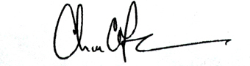
Charles Leocha
President, Travelers United

cc: Joel Szabat
Arjun Garg
David Short
Todd Homan
Blane Workie
Bonnie Dragotto
Ben Taylor

